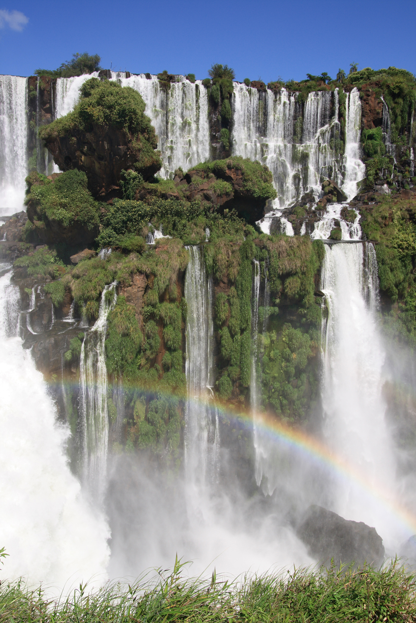

13-days / 12-nights

Explore Argentina


Itinerary Summary

No. | Date | Location | Details | Meals | Hotel | Nts
 | Day 01 | Depart | Depart Heathrow | - | Overnight Flight | 1
1 | Day 02 | Buenos Aires | Arrive in Buenos Aires | - | Intersur Recoleta | 4
 |  |  | Half day city tour | B
 | Day 03 |  | Day at leisure, evening show & dinner | BD
 | Day 04 |  | Day at leisure | B
2 | Day 05 | El Calafate | Air & road transfer to El Calafate | B | Posada Los Álamos | 3
 | Day 06 |  | Full day excursion to the Perito Moreno Glacier | B
 | Day 07 |  | Full day all Glacier Navigation | B
3 | Day 08 | Iguazú Falls | Air & road transfer to Iguazú Falls | B | Panoramic Hotel Iguazú | 3
 | Day 09 |  | Full day tour of the Argentine side of the falls | B
 | Day 10 |  | Half day tour of the Brazilian side of the falls | B
 | Day 11 | Depart | Meet the return flights to the UK | B | -
 | Day 12 | Heathrow | Arrive back in the UK | - | -
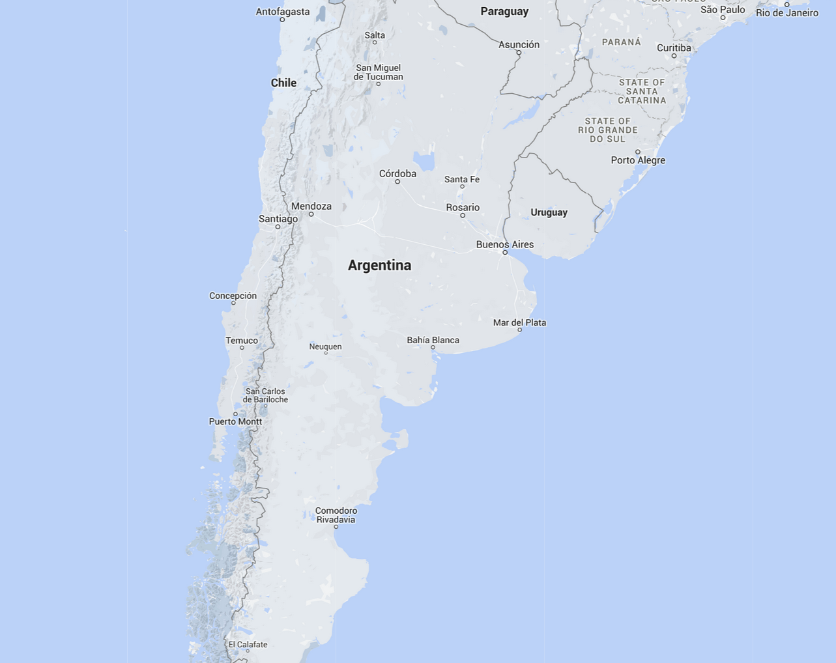



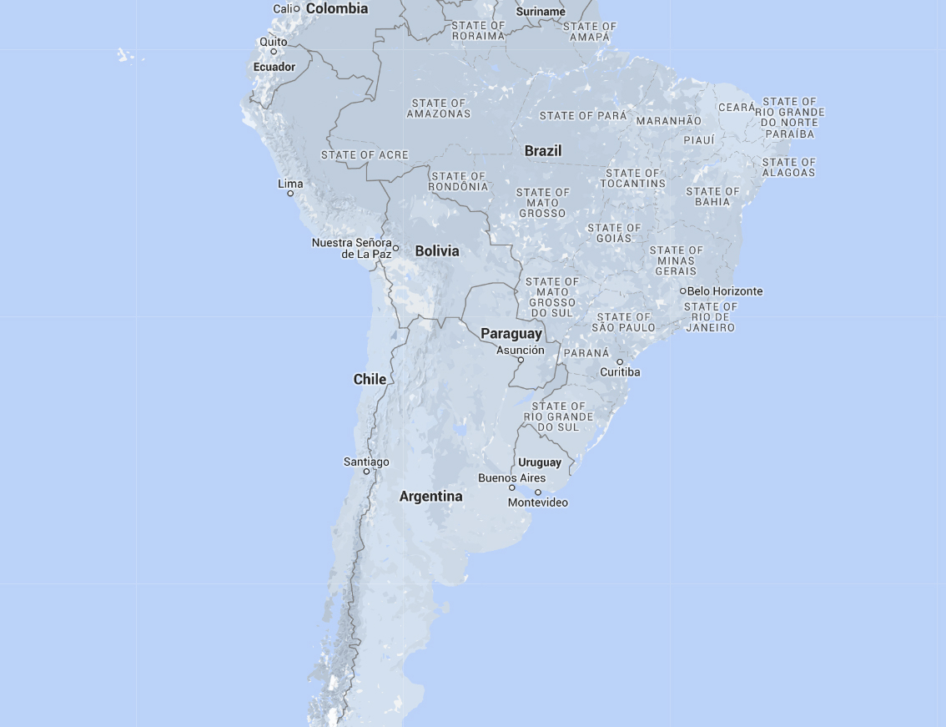

 | Day 01 | Heathrow – overnight flight

Depart Heathrow flying with British Airways.

 | BA245 | Economy | Dep: Heathrow T5 22:25 | Arr: Buenos Aires Intl. 08:10 (Day 2)

 | Day 02 | Buenos Aires

Private transfer on arrival to your hotel.

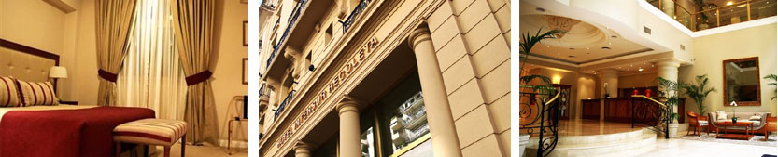

Hotel Intersur Recoleta

1 x Executive Callao Room on a Bed & Breakfast basis for 4-nights
Combining classic architecture with luxurious interiors, Intersur Recoleta is located in the vibrant and exclusive area of Recoleta only 4km from the domestic airport. Intersur Recoleta has elegant rooms. Intersur is only 7 blocks from the Museum of Fine Arts and 4 blocks from the famous Recoleta Cemetery. The trendy restaurant district, Puerto Madero, is a 10-minute drive. A buffet breakfast with pastries and croissants is served daily at Recoleto Bar, and guests can dine á la carte at Marcelo Restaurant.

 | Day 03 | Buenos Aires
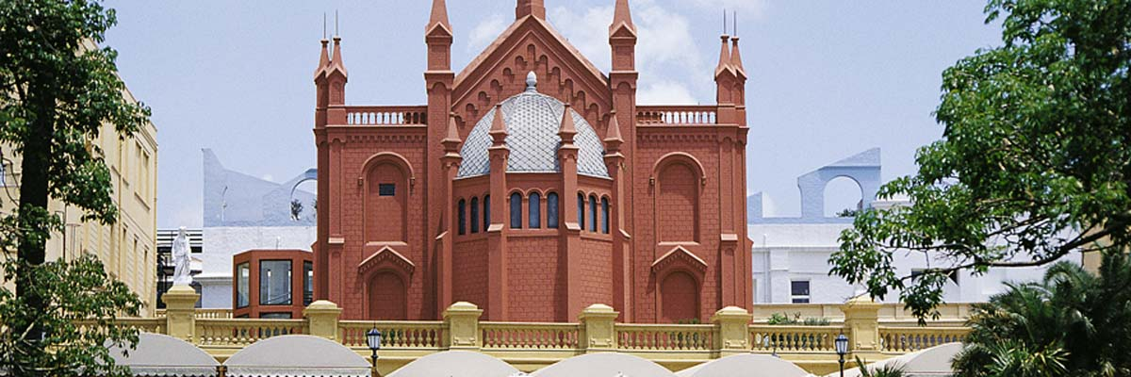
Shared half day city tour
Cosmopolitan and vibrant, Buenos Aires is a modern capital city with a distinctly European feel. There are many good museums, plenty of green open spaces and the architecture is striking. Away from the centre, several of the traditional neighbourhoods still remain. San Telmo has a quaint faded appeal with cobbled streets which really come alive on Sundays when the weekly antiques market is held. The area of La Boca, established by Italian immigrants, is well worth a visit to see the colourful buildings. Synonymous with Argentina, Eva Peron’s final resting place can be seen amongst the grand and ornate surroundings of the Recoleta Cemetery.

 | Day 04 | Buenos Aires

Day at leisure to explore Buenos Aires.
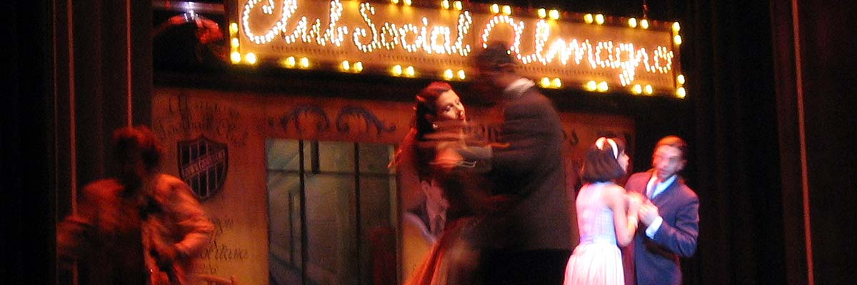

Shared evening excursion to Dinner & Tango show at Esquina Carlos Gardel
Named after the greatest tango singer of all, the ‘Esquina Carlos Gardel’ is located on the site of the ‘Chanta Cuastro’ restaurant where Gardel used to meet friends in the 1920s and ‘30s to eat, drink and sing late into the night, and is acknowledged as the city’s premier Dinner & Tango Show. The superb food and service, together with the stylish art nouveau interior, recreate the sophisticated and luxurious atmosphere of that era. The show is a spectacular mix of live tango music, singing and dancing and features some of the most talented performers in Buenos Aires.

 | Day 05 | Buenos Aires

Day at leisure.

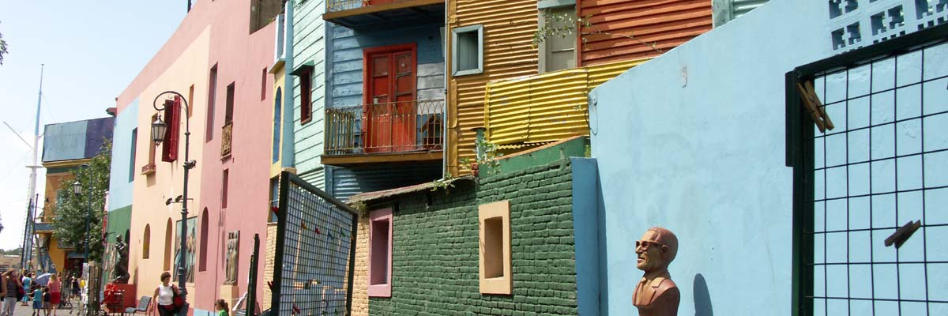

 | Day 06 | Buenos Aires – el calafate

Private transfer to Buenos Aires Domestic Airport for your onward flight flying with LAN.

 | LA4430 | Economy | Dep: Buenos Aires Domestic 15:20 | Arr: El Calafate 18:45

Private transfer on arrival to your hotel.
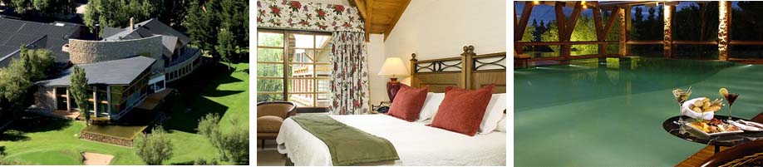
Posada Los Álamos

1 x Standard Room on a Bed & Breakfast basis for 3-nights
Located a few blocks away from the centre of town, the Posada Los Alamos is El Calafate’s best hotel. The hotel has 144 rooms with beautiful views of the gardens and the Andes. All rooms feature LCD TVs with cable channels, CD players and minibars and there is complementary wireless high-speed internet access. There is also a small golf course, spa, indoor pool and steam room at the hotel and for those looking for a more active stay there is a fitness centre on site and fantastic walking nearby. Posada Los Álamos offers guests multiple dining options at the restaurant, café and bar/lounge and prides itself on its delicious traditional dishes.

 | Day 07 | Buenos Aires – el calafate
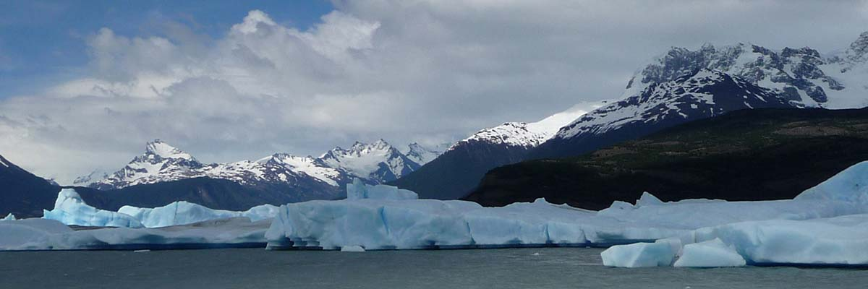

Shared full day excursion to the Perito Moreno Glacier
A two hour drive from El Calafate takes you to the Perito Moreno Glacier, considered by many to be the most beautiful glacier in the world. Wonder at the spectacle that is the 180 foot high, 3 mile wide and 20 mile long mass of ice. Certainly one of the most spectacular natural wonders in South America, the brilliant white glacier is slowly retreating and you will not have to wait for long before a large chunk of ice breaks away and crashes into the lake below. You will walk along the paths located in front of the glacier’s western wall, allowing you to view this natural wonder from a variety of different viewpoints.

 | Day 08 | el calafate
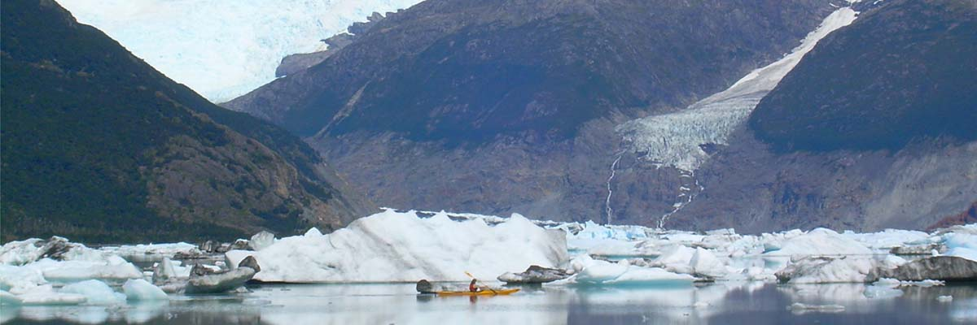

Full day shared All Glacier Navigation
A scenic boat ride amongst the icebergs on Lago Argentina. The tour begins from Punta Banderas and sails along its north arm to arrive at the massive Upsala glacier, one of the largest in South America. You will be greeted with breath-taking vistas as the crystal blue ice meets vast blue skies and Argentine mountains tower in the background. Sail on to Onelli Bay which is scattered with magical blue icebergs whose intensity varies with age.

 | Day 09 | el calafate - Iguazú Falls

Private transfer to the airport for your onward with LAN.

 | LA4438 | Economy | Dep: El Calafate 11:10 | Arr: Buenos Aires Domestic 14:08

Collect luggage and check-in for your onward flight to Iguazú Falls flying with Aerolineas Argentinas.

 | AR1734 | Economy | Dep: Buenos Aires Domestic 16:30 | Arr: Puerto Iguazú 18:15

Private transfer on arrival to your hotel.
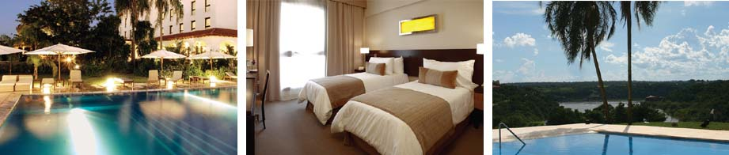
Panoramic Hotel Iguazú

1 x Standard Room on a Bed & Breakfast basis for 3-nights
Panoramic Hotel Iguazú is a sophisticated five-star hotel which boasts fantastic panoramic views from its hilltop location. The hotel has 91 rooms, a restaurant which serves delicious meals influenced by typical flavours of the region, a bar and a café. The swimming pool is surrounded by tropical gardens and boasts a panoramic view of the Three Frontiers. The hotel also offers Roman Baths, a playground and a fitness centre.

 | Day 10 | Iguazú Falls

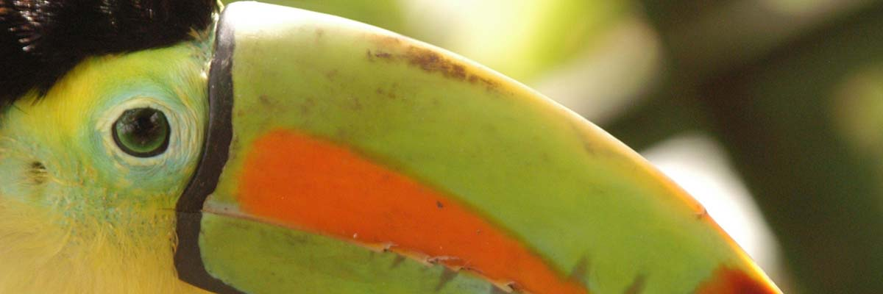
Shared full day tour of the Argentine side of the falls
Flowing between the Argentine and Brazilian border and surrounded by lush tropical rainforest, there are a total of 275 falls that thunder down into the mighty Iguazú River. On the Argentine side there are a number of pathways that take you up, under and often right next to many of the biggest falls. Over on the Brazilian side you are rewarded with a fantastic panorama of the falls. Early morning and late evening are particularly spectacular, tourist numbers are lower and the sky is filled with toucans and parrots returning home to roost. The surrounding national park is also well worth exploring, wander along the forest floor to see beautiful butterflies and a host of tropical birds.

 | Day 11 | Iguazú Falls

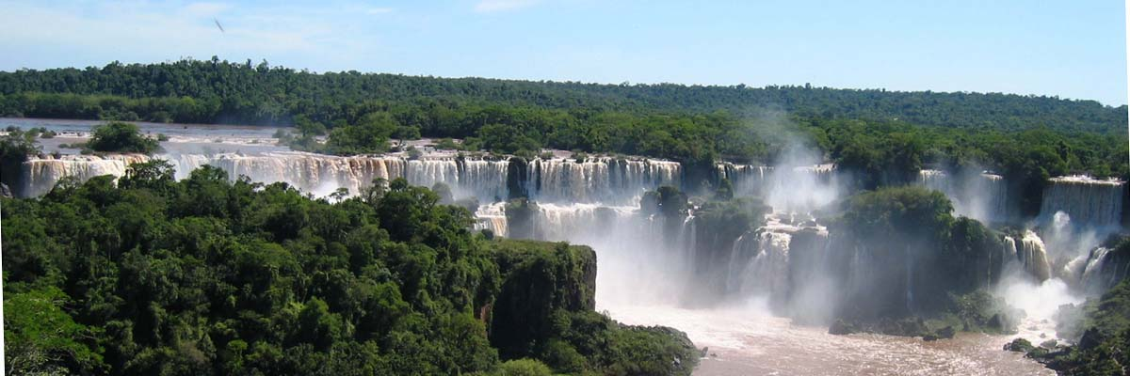
Shared half day tour of the Brazilian side of the falls
The trip begins at the Iguassu National Park with a drive through the lush, subtropical vegetation of the park en route to the falls. Take a stroll on the trail that descends down the canyon, to offer panoramic views of more than 240 falls. Embark on the glass elevator up the cliff face for an exquisite view from the upper deck. The Iguassu National Park along with its ‘sister’ park in Argentina form the most significant remaining rainforest in the southern cone of South America which along with the waterfalls, have been declared a National Heritage Site by UNESCO. You may end the tour with a visit to the artisans fair.

 | Day 12 | Iguazú Falls - depart

Private transfer to Foz du Iguassu airport to meet your return flights with GOL and British Airways.

 | G31383  BA246 | Economy  Economy | Dep: Foz Do Iguassu 12:43  Dep: Sao Paulo Intl 16:15 | Arr: Sao Paulo Intl 14:15  Arr: Heathrow 07:20 (Day 13)

 | Day 13 | UK

Arrive back in the UK.
from £3,195.00 per person
Holiday Cost
20% deposit is required to secure this booking

Suggested Itinerary
- This is just a suggested itinerary which we can amend to fit your exact requirements.

Includes
- International flights as listed.
- All pre-payable airport departure taxes.
- Hotel accommodation as listed.
- Transfers as listed (on a shared basis unless specified as private).
- Meals as listed.
- Excursions as listed (on a shared basis unless specified as private).

Excludes
- Local departure taxes where applicable.
- Tips and gratuities.
- Any future currency surcharges.
- Any future airline fare, tax or fuel surcharges.*
*In the event of airfare /tax increases you will have the option to pay for your airfare in advance to avoid these increases.

Please Note
- The cost of this itinerary is based on 2 passengers sharing one room.
- All flights, accommodation and services are subject to availability at the time of booking.
- Air fares, taxes, schedules and routings are subject to change until ticket issue.

Booking Conditions
- Usually a deposit of 20% is required to secure a booking.
- The final balance would be due 10 weeks prior to departure.
- You can review our full booking conditions at: www.distinctiveamericas.com

Financial & Consumer Protection
- When you book with Distinctive World Travel you are safe in the knowledge that we are fully bonded with the Civil Aviation Authority and hold an Air Tour Operators Licence (ATOL 9027).
www.caa.co.uk/ATOL 9027
- We are a member of AITO (Association of Independent Tour Operators) which represents the UK’s 140 top specialist tour operators and prides itself on providing the highest level of customer satisfaction by concentrating on: Choice, Quality and Service.
www.aito.co.uk

For more information or to discuss this quote please contact us on:
t: 01242 890 555
e: sales@distinctiveamericas.com
www.distinctiveamericas.com

